IID209: Microbial Communities and the Human Microbiome, Spring 2024

Final project

**Comparative Effects of Bovine MFGM-Enriched and Standard Formulas on Infant Gut Microbiome Development**

Cheryl Gu, Haya Alhmly, Yiching Chen, Emily King, Curtis Huttenhower

In the early life of infants, approximately the first two to three years after birth, the composition of infant gut microbiome develops and changes greatly according to the daily dietary intake and environmental exposure. Disruptions in gut microbiota during this early period can lead to a range of long-term health issues, including inflammatory disorders, autoimmune diseases, neurological disorders, and obesity. (Pantazi, 2023) Human milk is considered the gold standard in early-life nutrition due to many bioactive components, including milk fat globule membrane (MFGM). MFGM is recognized for its multifunctional role in enhancing neurodevelopment, modulating the immune response, and providing protection against pathogens. However, most standard formular infant milk historically discarded the MFGM fraction during the manufacturing process. (Hernell et al., 2016)

Recent research has explored the potential of bovine MFGM supplemented formulas to mimic the beneficial effects of human milk, leading to increased interest in adding back this component in infant formulas milk (Timby et al., 2017). These studies suggest that supplementation with bovine MFGM could lead to developmental outcomes in infants similar to those observed in breastfed infants, especially in terms of gut microbiota composition and metabolic functions.

However, most of the previous studies primarily focused on broad age ranges. Given that infants would be given other complementary food together with milk after about 4 to 6 months, the effect of solely infant formulas milk particularly on developmental stages within the first year of life remains unknown. Also, since the dynamic changes rapidly in the infant gut microbiome and metabolome during this period, it is thus crucial to investigate how these changes vary at specific developmental milestones. In this project, we aim to target on two critical age time points of 4 months and 12 months, which are key periods for the introduction of solid foods and other dietary transitions, and we will investigate specific impacts of bovine MFGM-enriched formula on the gut microbiomes of infants compared to the standard formulas. This will provide novel insights into how MFGM influences gut microbial composition and activity during significant dietary transitions. Through this research, we hope to contribute valuable data to the ongoing discussion on optimizing infant formula composition to better emulate the benefits of natural breastfeeding.

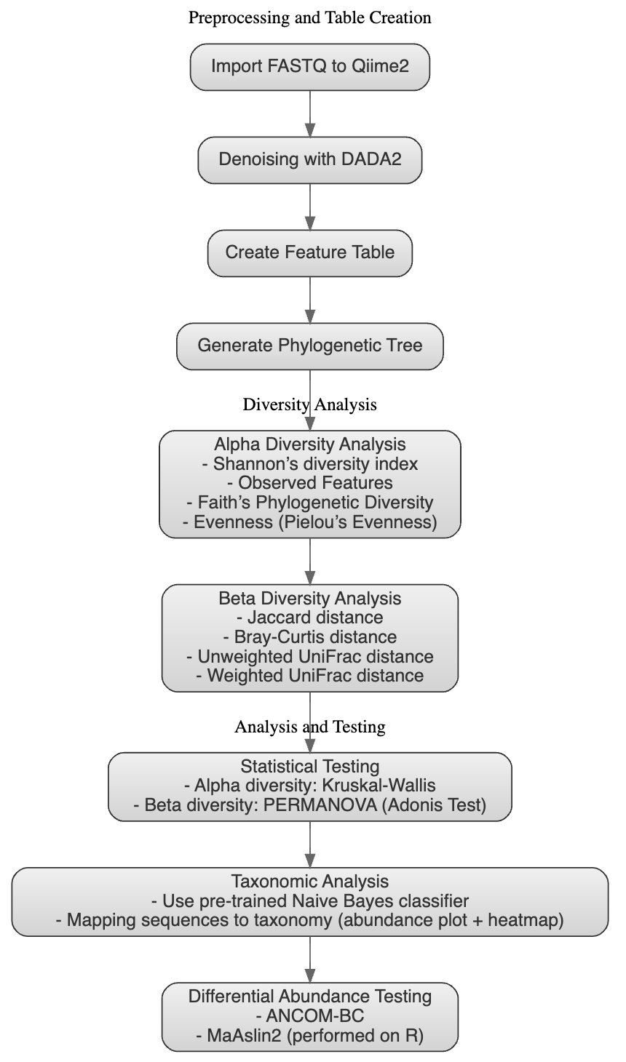Our analytical pipeline, as delineated in the workflow diagram (**Figure 1**), starts with importing the 16s amplicon rRNA sequencing reads into the QIIME2 microbiome bioinformatics platform. (<https://docs.qiime2.org/2024.2/>) These sequences then underwent denoising and clustering via DADA2 method, including quality filtering and dereplication, as well as the creation of a feature table detailing the amplicon sequence variants (ASVs) within the samples. Subsequently, we assigned the taxonomy to the sequences in the ASV table, using a pre-trained Naive Bayes classifier that was trained on the Silva 138 99% OTUs from the V4 region. (where 16S that was sequenced in this analysis, bound by the 515F/806R primer pair) We then performed alpha diversity analysis using multiple indices—Shannon's diversity index, observed features, Faith's phylogenetic diversity, and evenness to assess within-sample diversity. Beta diversity was evaluated using Jaccard and Bray-Curtis distances, alongside weighted and unweighted UniFrac distances, to explore community dissimilarities between samples. For hypothesis testing, we applied statistical methods such as Kruskal-Wallis for alpha diversity and PERMANOVA for beta diversity. Lastly, the differential abundance analysis using ANCOM-BC to identify statistically significant differences in microbial populations We verified this result using a comprehensive R package MaAsLin2 (<https://huttenhower.sph.harvard.edu/maaslin/>), thereby providing a comparable examination of the effects of dietary intake, in specific the infant formulas, on the development of infants gut microbial communities.

**Figure 1: Overview of workflow for microbial community analysis using 16s rRNA amplicon sequencing data.** Demonstrate the comprehensive workflow utilized in our study to analyze the development of the infant gut microbiome using QIIME2. This pipeline integrates several bioinformatics tools to process, analyze, and visualize high throughput sequencing data, providing a robust framework for understanding microbial community dynamics. Each step in the workflow is designed to ensure accurate data handling, from sequence importation and denoising to detailed statistical and taxonomic analyses.

In examining the alpha diversity of infant microbiota in 4 months vs. 12 months, specifically, the richness and evenness of the taxa represented in Shannon index revealed significant variations in diversity over two time points. At 4 months, infants fed with breast milk (BF_4) exhibited significantly higher microbial diversity compared to those fed standard formula (SF_4) and experimental formula (EF_4), with Kruskal-Wallis H values of 23.48 (p = 1.260277e-06) and 21.75 (p = 3.098968e-06), respectively. This differential trend across diets with the experimental formula group, however, was shown not statistically significant at the 12-month mark (H = 1.453934, p = 0.2278978). Comparisons within the two formula groups between the two time points showed significant shifts in diversity. For infants receiving the experimental formula, diversity significantly increased from 4 months (EF_4) to 12 months (EF_12) (H = 30.47400, p = 3.389997e-08). The standard formula group, in contrast, had no significant change in diversity from SF_4 to SF_12 (H = 0.049827, p = 0.8233638). (**Figure 2**) Overall, these results suggests that the experimental formula may support a development of microbial diversity closer to that observed in breastfed infants, particularly as early infant life stages, and the gut microbial diversity is associated with different feeding diets, which also become more apparent over time.

**Figure 2: Alpha Diversity and Statistical Analysis of Infant Gut Microbiome Across Different Feeding Regimens.** A comprehensive overview of the microbial alpha diversity within the infant gut microbiome as influenced by different feeding regimens and the statistical validation of these differences. **(A)** Box plots depicting the Shannon index across different infant feeding groups and time points, showing a general trend where experimental formula tends to support diversity close to that of breastfed infants, particularly at 12 months.  **(B)** Results of the Kruskal-Wallis pairwise comparisons for the Shannon entropy across the feeding groups and time points, which details the pairwise statistical analyses confirming significant differences, particularly between the formula-fed groups at different ages, highlighting the impact of feeding choices on gut microbiome development.

In our analysis of beta diversity using the Weighted UniFrac distance metric, significant differences were observed across the infant feeding groups and time points. The principal coordinate analysis (PCoA) plot illustrates the clustering patterns between the different groups, highlighting two distinct microbial clusters shown in regard of two different timepoints. In addition, the separation from three diet regimens also show consistency that the experimental formulas tend to emulate better in microbiota composition to the Breastfed, compared with the standard formulas. The Adonis test, a type of PERMANOVA is used to evaluate the significance of the differences. The results showed that the variation in microbial community composition is significantly associated with the different feeding groups and time points, as the model explained approximately 32.27% of the variance (R² = 0.322718) with a p-value of 0.001, indicating strong statistical significance. (**Figure 3**) This further suggests that the type of infant feeding and the age at which the samples were collected play critical roles in shaping the gut microbiome community, considering the weighted effects of phylogenic distances from diverse taxa.

**Figure 3: Beta Diversity and Statistical Analysis of Infant Gut Microbiome Across Different Feeding Regimens.** A comprehensive overview of the microbial beta diversity within the infant gut microbiome as influenced by different feeding regimens and the statistical validation of these differences. **(A)** Weighted UniFrac distances displayed through a PCoA plot, illustrating distinct clustering of microbial communities based on feeding type and collection time. Each point represents an individual sample, with shapes and colors corresponding to different groups: BF (Breastfed), EF (Experimental Formula), and SF (Standard Formula) at 4 months (red) and 12 months (blue). **(B)** Results of the Adonis test for beta diversity, showing degrees of freedom (DF), sum of squares (SumOfSqs), mean squares (MeanSqs), F Model value (FModel), proportion of variance explained (R²), and the p-value (Pr(>F)), demonstrating significant effects of feeding regimen and time on microbial community composition.

The taxonomic composition by order level is visualized in the stacked bar plot, revealing diverse bacterial communities across the samples in infants at 4 months vs. 12 months of age. Predominant phylum include Firmicutes, Bacteroidota, and Actinobacteria, with notable variation in relative abundances among different samples. Firmicutes are generally the most abundant, particularly the orders Lachnospirales, Clostridiales, and Eubacteriales, which are well-known for their roles in fermenting dietary fibers into short-chain fatty acids beneficial for host health. The presence of Bacteroidales and Actinomycetales suggests a complex community structure capable of various metabolic functions, including polysaccharide degradation. We also observed that Bifidobacteriales was the most dominant order in 4 month infants, but has decreased amount and be replaced as Lachnospirales in 12 month infants. The shift from Bifidobacteriales to Lachnospirales suggests a maturation of the gut ecosystem as infants transition from milk-based diets to more varied solid foods. Bifidobacteriales are crucial for their role in breaking down human milk oligosaccharides, which are abundant in breast milk and not in solid foods. As the diet diversifies, Lachnospirales, known for their ability to ferment complex carbohydrates, become more prominent, reflecting dietary changes and their impact on microbial colonization and metabolic activity. This transition may influence various health aspects, including nutrient metabolism and immune system development, emphasizing the importance of dietary inputs in shaping the gut microbiome's evolution during critical early life stages.

**Figure 4: Taxonomic Distribution Across Infant Gut Microbiome Samples in 4 months vs. 12 months.** The taxonomy abundances demonstrate the relative abundance of various bacterial taxa across multiple samples. The plot illustrates the dominance of specific taxa such as Firmicutes and Bacteroidota, alongside less abundant but ecologically significant groups, highlighting the intricate balance of the infant gut microbiome.

For the differential abundance analysis, both ANCOM-BC and MaAsLin2 yielded similar results, showcasing only the three diet regimens with 4 months infants group showed statistical significance with some taxa either being enriched and depleted within certain diet groups. The ANCOM-BC analysis highlights taxa that are significantly enriched or depleted in each feeding group compared to the others within 4-month group. For infants fed breast milk (BF_4), genera such as Lactobacillus and Bifidobacterium show significant enrichment, indicating their prominent role in the gut microbiomes of breastfed infants due to the presence of human milk oligosaccharides that favor their growth (Turroni et al., 2012). On the contrary, genera like Staphylococcus and Enterococcus are markedly depleted in this group. In the experimental formula group (EF_4), notable taxa such as Turicibacter and Ruminococcus are enriched, suggesting that the composition of the experimental formula may support the growth of these bacteria, potentially influencing metabolic activities like short-chain fatty acid production (Gomez-Gallego et al., 2016). In contrast to the decrease of Staphylococcus and Enterococcus that we found previously for the Breast-fed group, the standard formula group (SF_4) shows a significant enrichment of Staphylococcus and Enterococcus. This could reflect differences in the immunological and microbial interactions within the gut. Taxa such as Bifidobacterium and Lactobacillus, typically associated with health benefits in early life, are notably depleted in the standard formula-fed infants. We explained the reason we cannot find any differences in diet group effects within 12-months group is that the infant gut microbiota is more homogenous and stabilized with the introduction of milk as well as other complementary food.

**Figure 5: Differential Abundance of Microbial Taxa Across Infant Feeding Regimens at 4 Months.** A differential abundance forest plot for three infant feeding groups at 4 months, using ANCOM-BC for analysis. The plot highlights specific microbial taxa that are either significantly enriched or depleted in **(A)** breastfed (BF_4), (**B)** experimental formula-fed (EF_4), and **(C)** standard formula-fed (SF_4) infants. This visualization aids in understanding how different feeding strategies impact the compositional landscape of the infant gut microbiome, with implications for nutritional strategies and health outcomes.

In conclusion, while our study demonstrated consistent findings with the previous research as well as new insights on the comparative 4 months vs. 12 months infant dietary effects on gut microbiota composition. These findings must be interpreted with caution given the limitations regarding dietary diversity and taxonomic depth. While this study offers valuable insights into the microbial impacts of early-life nutrition, there are still few limitations to consider. First, a subgroup of infants in the 4-month group was exclusively breastfed or fed the study formula without exposure to complementary foods. This restriction could influence the generalizability of our findings to wider infant populations where early introduction of complementary foods is common. Additionally, our taxonomic classification relied on a classifier that lacks comprehensive species-level identification, which might limit our understanding of finer microbial community structures and their functional implications between the groups. We suggested the future research extend to a broader dietary scope, possibly incorporate MGFM in another form of supplementary as a comparison group and leverage more detailed taxonomic tools to further elucidate the intricate relationship between diet and the developing gut microbiome in the species level of taxonomy.

References

Bolyen, E., Rideout, J. R., Dillon, M. R., Bokulich, N. A., Abnet, C. C., Al-Ghalith, G. A., Alexander, H., Alm, E. J., Arumugam, M., Asnicar, F., Bai, Y., Bisanz, J. E., Bittinger, K., Brejnrod, A., Brislawn, C. J., Brown, C. T., Callahan, B. J., Caraballo-Rodríguez, A. M., Chase, J., Cope, E. K., Da Silva, R., Diener, C., Dorrestein, P. C., Douglas, G. M., Durall, D. M., Duvallet, C., Edwardson, C. F., Ernst, M., Estaki, M., Fouquier, J., ...Caporaso, J. G. (2019). Reproducible, interactive, scalable and extensible microbiome data science using QIIME 2. *Nature Biotechnology, 37*, 852–857. https://doi.org/10.1038/s41587-019-0209-9

Brink, L. R., & Lönnerdal, B. (2020). Milk fat globule membrane: The role of its various components in infant health and development. *The Journal of Nutritional Biochemistry, 85*, 108465. https://doi.org/10.1016/j.jnutbio.2020.108465

Callahan, B. J., McMurdie, P. J., Rosen, M. J., Han, A. W., Johnson, A. J. A., & Holmes, S. P. (2016). DADA2: High-resolution sample inference from Illumina amplicon data. *Nature Methods, 13*(7), 581–583. <https://doi.org/10.1038/nmeth.3869>

Gomez-Gallego, C., Garcia-Mantrana, I., Salminen, S., & Collado, M. C. (2016). The human milk microbiome and factors influencing its composition and activity. Seminars in fetal & neonatal medicine, 21(6), 400–405. https://doi.org/10.1016/j.siny.2016.05.003

He, X., Parenti, M., Grip, T., Lönnerdal, B., Timby, N., Domellöf, M., Hernell, O., & Slupsky, C. M. (2019). Fecal microbiome and metabolome of infants fed bovine MFGM supplemented formula or standard formula with breast-fed infants as reference: A randomized controlled trial. *Scientific Reports, 9*(1), 11589. https://doi.org/10.1038/s41598-019-47953-4

Hernell, O., Timby, N., Domellöf, M., & Lönnerdal, B. (2016). Clinical benefits of milk fat globule membranes for infants and children. *The Journal of Pediatrics, 173*(Suppl), S60–S65. https://doi.org/10.1016/j.jpeds.2016.02.077

Mallick, H., Rahnavard, A., McIver, L. J., Ma, S., Zhang, Y., Nguyen, L. H., Tickle, T. L., Weingart, G., Ren, B., Schwager, E. H., Chatterjee, S., Thompson, K. N., Wilkinson, J. E., Subramanian, A., Lu, Y., Waldron, L., Paulson, J. N., Franzosa, E. A., Bravo, H. C., & Huttenhower, C. (2021). Multivariable association discovery in population-scale meta-omics studies. *PLoS Computational Biology, 17*(11), e1009442. https://doi.org/10.1371/journal.pcbi.1009442

Ma, J., Li, Z., Zhang, W., & others. (2020). Comparison of gut microbiota in exclusively breast-fed and formula-fed babies: A study of 91 term infants. *Scientific Reports, 10*(1), 15792. https://doi.org/10.1038/s41598-020-72635-x

Pantazi, A. C., Balasa, A. L., Mihai, C. M., Chisnoiu, T., Lupu, V. V., Kassim, M. A. K., Mihai, L., Frecus, C. E., Chirila, S. I., Lupu, A., Andrusca, A., Ionescu, C., Cuzic, V., & Cambrea, S. C. (2023). Development of gut microbiota in the first 1000 days after birth and potential interventions. Nutrients, 15(16), 3647. <https://doi.org/10.3390/nu15163647>

Turroni, F., Peano, C., Pass, D. A., Foroni, E., Severgnini, M., Claesson, M. J., Kerr, C., Hourihane, J., Murray, D., Fuligni, F., Gueimonde, M., Margolles, A., De Bellis, G., O'Toole, P. W., van Sinderen, D., Marchesi, J. R., & Ventura, M. (2012). Diversity of bifidobacteria within the infant gut microbiota. PloS one, 7(5), e36957. https://doi.org/10.1371/journal.pone.0036957

Yilmaz, P., Parfrey, L. W., Yarza, P., Gerken, J., Pruesse, E., Quast, C., Schweer, T., Peplies, J., Ludwig, W., & Glöckner, F. O. (2014). The SILVA and "All-species Living Tree Project (LTP)" taxonomic frameworks. Nucleic Acids Research, 42, D643-D648. https://doi.org/10.1093/nar/gkt1209